lhoSelenium command

 Fetching a web page

There are two methods to fetch a web page:

* Using Get method

1. driver.get("www.javatpoint.com")

* Using Navigate method

1. driver.navigate().to("https://javatpoint.com/selenium-tutorial");

2. Locating forms and sending user inputs

1. driver.findElement(By.id("lst-ib")).sendKeys("javatpoint tutorials");

 Clearing User inputs

The clear() method is used to clear the user inputs from the text box.

1. driver.findElement(By.name("q")).clear();

4. Fetching data over any web element

Sometimes we need to fetch the text written over a web element for performing some assertions and debugging. We use getText() method to fetch data written over any web element.

1. driver.findElement(By.id("element567")).getText();

5.Performing Click event

The click() method is used to perform click operation on any web element.

1. driver.findElement(By.id("btnK")).click();

6. Navigating backward in browser history

1. driver.navigate().back();

7. Navigating forward in browser history

1. driver.navigate().forward();

8. Refresh/ Reload a web page

1. driver.navigate().refresh();

Closing Browser

1. driver.close();

10. Closing Browser and other all other windows associated with the driver

1. driver.quit();

11. Moving between Windows

1. driver.switchTo().window("windowName");

13. Moving between Frames

1. driver.switchTo().frame("frameName");

14. Drag and Drop

Drag and Drop operation is performed using the Action class.

WebElement element = driver.findElement(By.name("source"));

WebElement target = driver.findElement(By.name("target"));

(**new** Actions(driver)).dragAndDrop(element, target).perform()

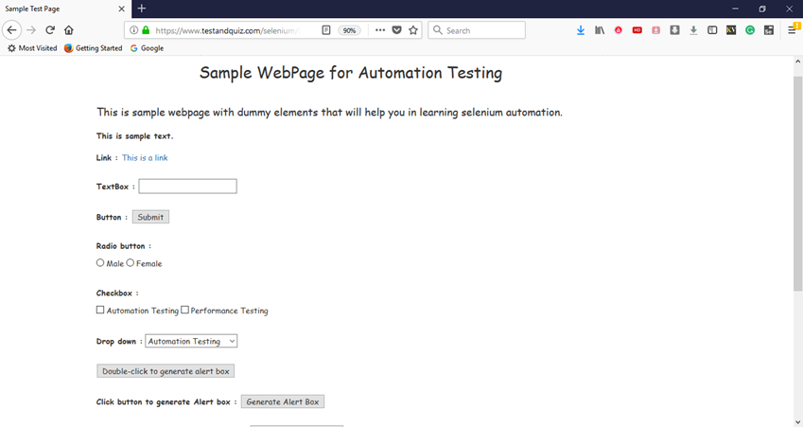

1. **import** org.openqa.selenium.By;
2. **import** org.openqa.selenium.WebDriver;
3. **import** org.openqa.selenium.firefox.FirefoxDriver;
4. **import** org.openqa.selenium.remote.DesiredCapabilities;
5. **import** org.openqa.selenium.support.ui.Select;
7. **public** **class** Second {
9. **public** **static** **void** main(String[] args) {
11. // System Property for Gecko Driver
12. System.setProperty("webdriver.gecko.driver","D:\\GeckoDriver\\geckodriver.exe" );
14. // Initialize Gecko Driver using Desired Capabilities Class
15. DesiredCapabilities capabilities = DesiredCapabilities.firefox();
16. capabilities.setCapability("marionette",**true**);
17. WebDriver driver= **new** FirefoxDriver(capabilities);
19. // Launch Website
20. driver.navigate().to("https://www.testandquiz.com/selenium/testing.html");
22. // Fetch the text "This is sample text." and print it on console
23. // Use the class name of the div to locate it and then fetch text using getText() method
24. String sampleText = driver.findElement(By.className("col-md-12")).getText();
25. System.out.println(sampleText);
27. // Use the linkText locator method to find the link and perform click using click() method
28. driver.findElement(By.linkText("This is a link")).click();
30. // Click on the textbox and send value
31. driver.findElement(By.id("fname")).sendKeys("JavaTpoint");
33. // Clear the text written in the textbox
34. driver.findElement(By.id("fname")).clear();
36. // Click on the Submit button using click() command
37. driver.findElement(By.id("idOfButton")).click();
39. // Locate the radio button by id and check it using click() function
40. driver.findElement(By.id("male")).click();
42. // Locate the checkbox by cssSelector and check it using click() function
43. driver.findElement(By.cssSelector("input.Automation")).click();
45. // Use Select class for selecting value from dropdown
46. Select dropdown = **new** Select(driver.findElement(By.id("testingDropdown")));
47. dropdown.selectByVisibleText("Automation Testing");
49. // Close the Browser
50. driver.close();
52. }
54. }